6/23/22

Loupe Browser Notes

(more information can be found at <https://support.10xgenomics.com/single-cell-gene-expression/software/visualization/latest/tutorial>)

**Preliminaries:**

* Need file with the .cloupe extension. These can be opened by the browser.
* Once the file is opened, the initial page should look something like this:

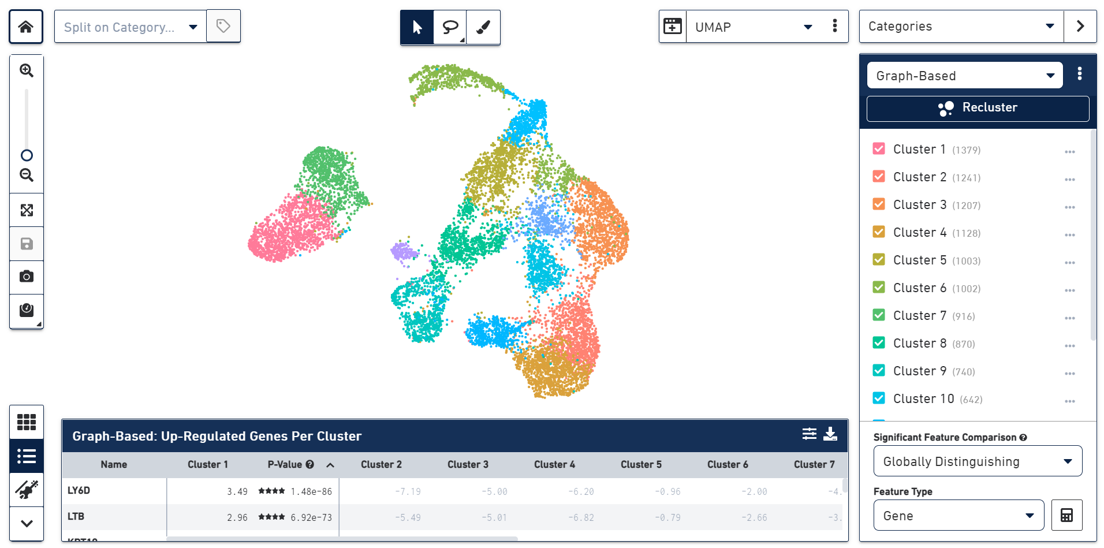

**List of Up-Regulated Genes**

* On the bottom of the page is a list of up-regulated genes in each cluster. In other words, singular cells are clustered by the genes they are most likely to express.
* The p-value is the adjusted p-value found by the Benjamini-Hochberg procedure <https://www.statisticshowto.com/benjamini-hochberg-procedure/> . This procedure is used to reduce the false-discovery rate.
* The stars next to the p-value are a metric to show if the p-value is less than 0.001, (four stars) up to 0.1 (one star).

**Heat Map**

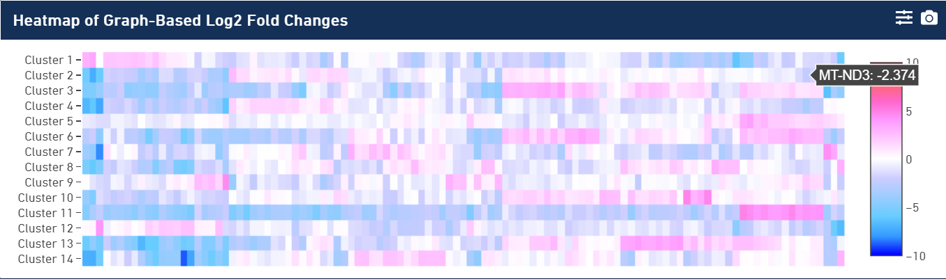

* The gene heatmap is used to show which genes are MOST unique in each cluster.
* By clicking on a tile in the heatmap, the graphic changes to show which cells express this gene. The gene on the left is more unique than the one on the right, since it is only expressed in two different clusters. The one on the right is expressed in at least five.
* 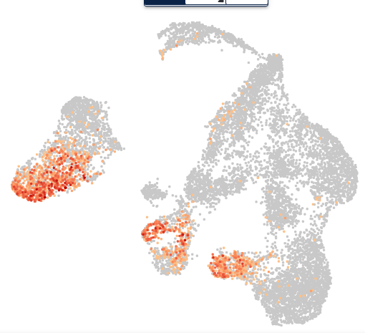 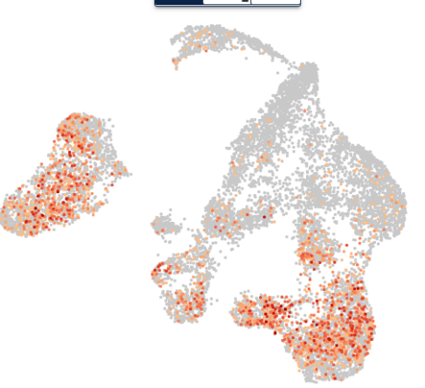

**Violin Plots**

* The third option in the bottom-left panel shows the violin plots of the gene/feature expression.
* From these plots, we see that most of the many possible genes are not expressed in each cluster but that there are some notable outliers that are heavily expressed. These outliers are characterized by the lines going up to a certain point.

